USN | 1 | M | S
M S RAMAIAH INSTITUTE OF TECHNOLOGY
(AUTONOMOUS INSTITUTE, AFFILIATED TO VTU)
BANGALORE – 560 054
SEMESTER END EXAMINATIONS – MAY/JUNE 2016

Course & Branch | : | B.E. - Common to all Branches | Semester | : | II
Subject | : | Engineering Mathematics –II | Max. Marks | : | 100
Subject Code | : | MAT201 | Duration | : | 3 Hrs

Instructions to the Candidates:
- Answer one full question from each unit.

 |  | UNIT – I
1. | a) | Write the derivative of arc length of a curve in polar form. | CO1 | (02)
 | b) | Show that: 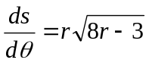 for the curve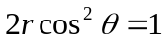. | CO1 | (03)
 | c) | Using Taylor’s series expand 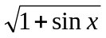 about 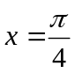 up to the fourth degree terms. | CO1 | (08)
 | d) | A rectangular box open at the top is to have volume of 108 cubic ft. Find the dimensions of the box requiring least material for its construction. | CO1 | (07)
2. | a) | Evaluate: 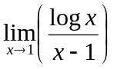 | CO1 | (02)
 | b) | Show that 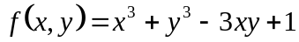 is minimum at the point (1, 1). | CO1 | (03)
 | c) | Expand 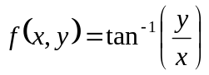 in powers of 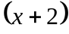 and up to the second degree terms. | CO1 | (08)
 | d) | If 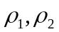be the radii of curvature at the extremities of any chord of the cardioid which passes through the pole then show that. | CO1 | (07)
 |  | UNIT – II
3. | a) | Define orthogonal trajectories. | CO2 | (02)
 | b) | Solve: 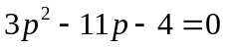 | CO2 | (03)
 | c) | A voltage 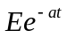 is applied at to a circuit of inductance and resistance . Show that the current at time is 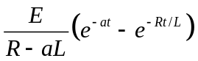 if initial current is zero | CO2 | (08)
 | d) | Solve: 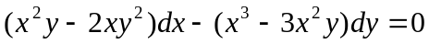 | CO2 | (07)
4. | a) | Define an integrating factor with an example. | CO2 | (02)
 | b) | Solve: 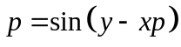 also find its singular solutions. | CO2 | (03)
 | c) | State Newton’s Law of cooling. If the temperature of the air in 30⁰C and the substance cools from 100⁰C to 70⁰C in 15 minutes find the time required so that temperature will be 40⁰C. | CO2 | (08)
 | d) | Show that the family of curves 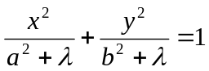 is self-orthogonal, where is the parameter. | CO2 | (07)
 |  | UNIT – III
5. | a) | Explain the working rule to find the P.I of the Linear differential equation 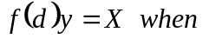 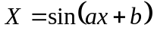. | CO3 | (02)
 | b) | Solve the Boundary value problem:  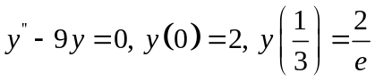 . | CO3 | (03)
 | c) | The differential equation of a simple pendulum is 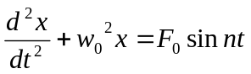 , where & 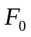are constants. If initially x= 0, 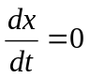, determine the motion when 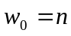 | CO3 | (08)
 | d) | Solve: | CO3 | (07)
6. | a) | Express the differential equation 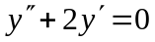 into a differential equation with constant coefficient. | CO3 | (02)
 | b) | Solve: 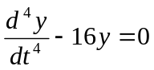. | CO3 | (03)
 | c) | Solve: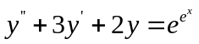 by the method of variation of parameter. | CO3 | (08)
 | d) | Solve: 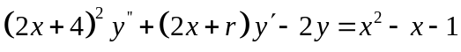 | CO3 | (07)
 |  | UNIT – IV
7. | a) | Define the Dirac-Delta function and sketch its graph. | CO4 | (02)
 | b) | Show that: 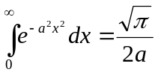. | CO4 | (03)
 | c) | Express the function 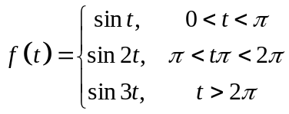in terms of the Heaviside function and hence find its Laplace transform. | CO4 | (08)
 | d) | Evaluate the integral 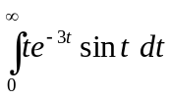 using Laplace transforms. | CO4 | (07)
8. | a) | Define function of exponential order. | CO4 | (02)
 | b) | Obtain the Laplace transform of 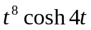. | CO4 | (03)
 | c) | Prove that:  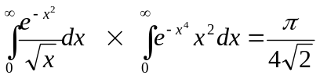 | CO4 | (08)
 | d) | Evaluate :  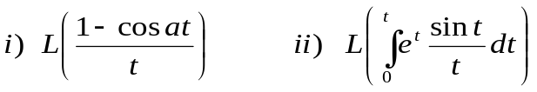 | CO4 | (07)
 |  | UNIT – V
9. | a) | Draw the graph of the periodic function.  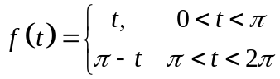 | CO5 | (02)
 | b) | Solve using Laplace transform. | CO5 | (03)
 | c) | State and prove convolution theorem. | CO5 | (08)
 | d) | The coordinates 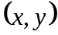 of a particle moving along a plane curve at any point , are given by 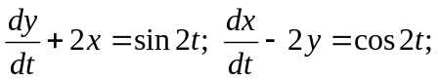  . If at , 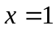and , show by using Laplace Transforms that the particle moves along the curve 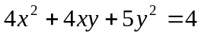 | CO5 | (07)
10. | a) | Define convolution of two functions. | CO5 | (02)
 | b) | Show that: | CO5 | (03)
 | c) | Using convolution theorem find inverse Laplace transform the following function 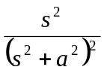 | CO5 | (08)
 | d) | Obtain the Laplace transform of the rectangular wave given by by following figure.  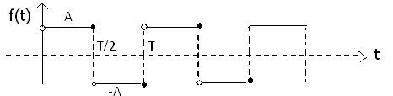 | CO5 | (07)

**********************

